HYBRID WILDERNESS FIRST RESPONDER RECERTIFICATION (HWRR)

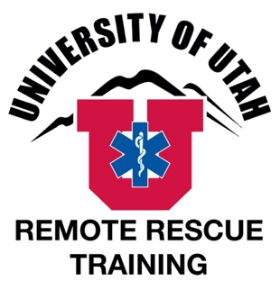
Sponsored by The University of Utah, Center for Emergency Programs, Remote Rescue Training & NOLS Wilderness Medicine

Dates: April 27 - 28, 2024
Cost: $425 Tuition only
Location: 290 South 1850 East, Salt Lake City, UT

Travel, Meals, and Lodging
Meals and Lodging
There is not a meal and lodging package available for this course. Salt Lake City has many hotels with prices in all budgets. The U of U Guest House (www.guesthouse.utah.edu/ or 801-587-1000) is walking distance from the classroom and provides the most convenient lodging. Any hotel in Salt Lake City near the University Trax line will make for an easy commute. There is no camping within the area of the course.

There are a several options for lunches within easy walking distance on campus (cafes and food trucks) that are open most days; details are available on the campus map. Or we recommend that you bring a lunch. There are sometimes events on campus that make parking difficult after lunch time; planning to not drive at lunch eliminates this problem.

Travel
The course will meet in room 117, HPER West Building, at the University of Utah, Salt Lake City Campus (290 South 18500 East, Salt Lake City, UT 84112). The HPR West Building is between the Huntsman Center Basketball Area and the Sorenson Arts and Education Complex on the U of U campus. Campus is ~15 minutes from I-15 or I-80, although traffic may cause delays, especially during rush hour.

Go to https://map.utah.edu for a campus map. Use the drop-down menus at the top to search for the HPR West Building and to show parking areas or food options.

Parking on campus on weekdays requires a parking permit. Permits may be purchased ahead of time online at https://utah.t2hosted.com/cmn/auth_guest.aspx. ”U” permits cost $11/day and convenient “U” lots are located east and south of the Huntsman Center; details are available on the campus map.

Weekend parking is free. Parking permits are enforced Monday to Friday, 7am-10pm.

Light rail service is provided near the HPR West building- University South Campus Station- via Trax (www.rideuta.com/) red line. The Utah Transit Authority also has regular bus service to the University of Utah.

Occasionally events on campus can complicate travel, parking or other logistics. We are not aware of any at this time.

Registration
How to Register
NOLS is collecting tuition and enrollment information for this course. Please register on the NOLS website.

Cancelation Policies
NOLS is taking all registration for this course. Please visit their policies page for an overview of cancelation and transfer policies.

For Questions about location and logistics, contact:
University of Utah, Center for Emergency Programs (UUCEP):
Office: (801) 581-4512
Websites: www.UUCEP.org
www.RemoteRescueTraining.com
Email: UUCEP@utah.edu
Rescue@utah.edu

For Questions about registration, contact:
NOLS Wilderness Medicine:
Office Hours: M-F from 8am-5pm MST
Phone: (866) 831-9001
wilderness_medicine@nols.edu
www.nols.edu/wilderness-medicine

