Wilderness First Responder (WFR)

Sponsored by Greenfield Community College & NOLS Wilderness Medicine

DATES: January 8th -17th, 2021
COST: $750.00
LOCATION: One College Drive, Greenfield, MA 01301

Travel, Meals, and Lodging
Meals and Lodging
Meals and lodging are not provided on this course. There is a grocery store and food options located within a mile as well as a few hotels located in the vicinity.

Travel

One Greenfield Drive, Greenfield, MA 01301

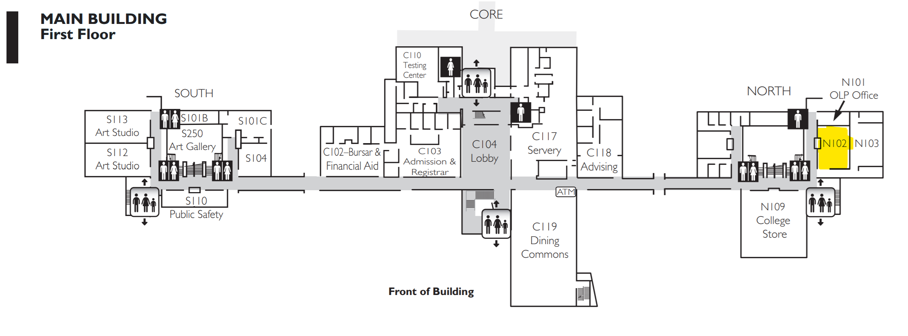

Registration
How to Register
Please visit https://www.gcc.mass.edu/adventure/certifications/ to register.

Cancelation Policies
If you cancel or withdraw from a course:
- Within 30 days of the course start date, tuition is non-refundable and non-transferable as per the following:
- Once the course begins, no refunds will be awarded. All course registrations are non-transferable.

For Questions about location, logistics, and registration, contact:

Greenfield Community College
Office Hours: M-F from 8am-4pm EST
Phone: 413.775.1000
Email: gasking@gcc.mass.edu
Website: https://www.gcc.mass.edu/

